|  |  |
| --- | --- |
| **Soal Tugas Mandiri**  *Assignment Case* |  |
| CPEN6098 /CPEN6108 /CPEN6109  Computer Networks |
| **Sistem Komputer**  *Computer System* | **E3-CPEN6098-AA01** |
| **Periode Berlaku** Semester Genap 2015/2016  ***Valid on*** *Even SemesterYear 2015/2016* | **Revisi 0**  *Revision 0* |

## Soal

*Case*

1. Wild-Sport Company wants to build a new network. You are requested to use **VLAN**. The required network devices to build their LAN are **2 switches and 8 computers**. The details is written below.

* This company **have 3 division with each division have different Network ID**:
  + **Climbing’s** address range **192.10.1.0 –192.10.1.255** as **VLAN 10**
  + **Caving ’s** address range **192.10.2.0 –192.10.2.255** as **VLAN 20**
  + **Hiking’s** address range **192.10.3.0 –192.10.3.255** as **VLAN 30**
* **Each floor must have 1 switch** to connect **each computer and another switch in another floor**.
* This company has **2 floors** building which have following details :
  + **First floor** has **2 computers** for **Climbing**, **1 computer** for **Caving** and **1 computer** for **Hiking**.
  + **Second floor** has **1 computer** for **Climbing**, **1 computer** for **Caving** and **2 computers** for **Hiking**.

1. This picture below show the **WLAN** which is requested by Wild-Sport Company for it’s new branch office.

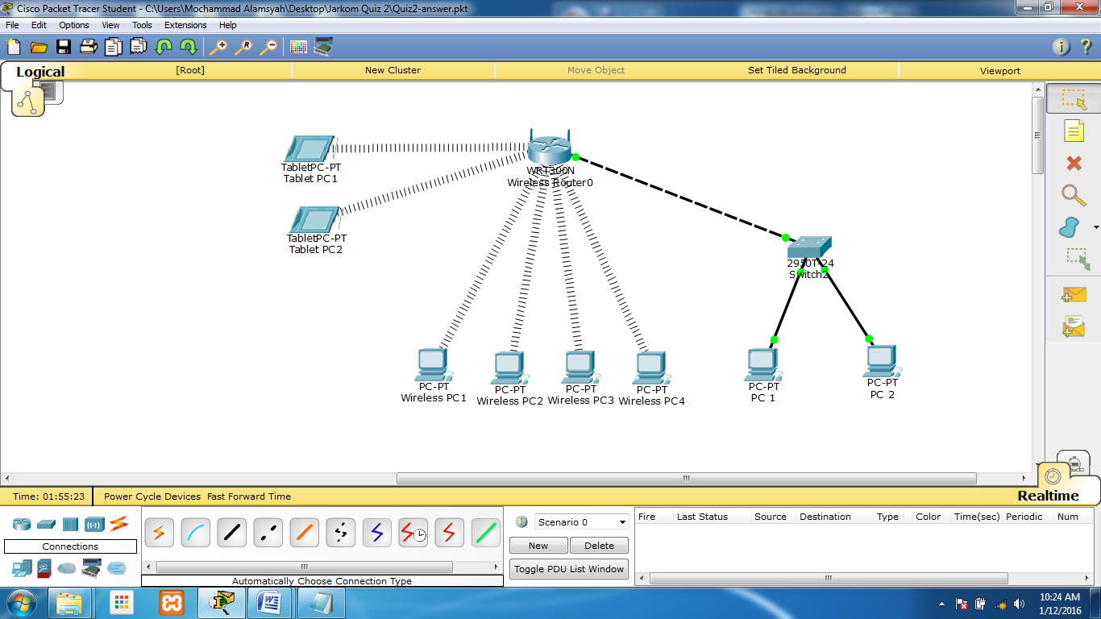

These are the detail of WLAN that is requested by Wild-Sport Company.

* **1 WIFI modem, protected by WPA2 personal with password**: @l4mL14R.
* **4 Wireless PCs, 2 Tablet PCs** and **2 PCs connected by cable**, **all their IP is obtained from DHCP** addressing.
* **SSID** based on company name.
* **Linksys WIFI IP address: 192.10.0.1**.
* **DHCP start IP address 192.10.0.10/24**.
* **Maximum number of users: 10**.
* All **computers must be able to send and receive packet from other computers**.

1. 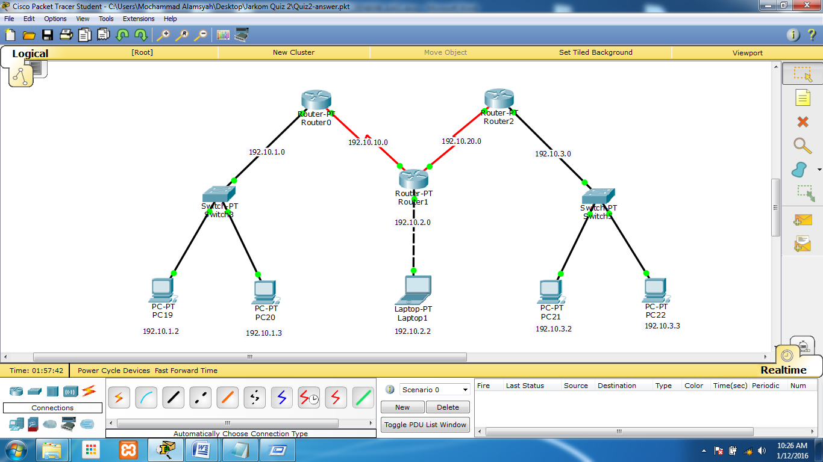This picture below show the **LAN** which is requested by Wild-Sport Company.

There are **3 networks** in the picture. **Assign an IP for each device** with an appropriate IP b**ased on which network they’re belong to**. Then set the **routing with OSPF**.

1. Wild-Sport Company wants to **build a new network** with **Router Mikrotik**. You as a Network Administrator was asked to **configure Router Mikrotik** that has been installed. The following requirement as followed:
   * **Ether 1** is an interface that **connect between router with internet Service Provider**.
   * **Ether 3** is an interface that **connect between internal network with the router**.
   * Configure router with following configuration as follow:

|  |  |
| --- | --- |
| **Anggrek Campus** | **Alam Sutera Campus** |
| ETH1 : 10.22.10**x**.20**y**/24  Gateway : 10.22.10**x**.1  LAN IP : 192.10.1y.10/24  DNS : 10.22.64.21 | ETH1 : 10.35.13x.20**y**/24  Gateway : 10.35.13x.1  LAN IP : 192.10.1y.10/24  DNS : 10.22.64.21 |

* NAT must be used to connect network to internet by using the IP that has been provided.
* For **Anggrek Campus**, Main router restricted ip between 10.22.10**x**.201 till 10.22.10**x**.208 to connect to internet.
* For **Alam Sutera Campus**, Main router restricted ip between 10.35.13x.201 till 10.35.13x.208 to connect to internet.

|  |  |
| --- | --- |
| **Anggrek Campus** | **Alam Sutera Campus** |
| **x = 1 for room number 601**  **x = 3 for room number 603** | **x = 1 for room number ASA1301**  **x = 2 for room number ASA1302** |